H |  | NANYANG JUNIOR COLLEGE  JC 2 Preliminary Examinations  Higher 1
CANDIDATE
NAME

CANDIDATE  NAME |  | Answers
CLASS |  |  |  | TUTOR’S NAME
CHEMISTRY |  |  |  | 8872/02
Paper 2 |  |  |  | 21 Sep 2010
 |  |  |  | 2 hours
Candidates answer on the Question Paper.
Additional Materials: Data Booklet
Writing Paper
Graph Paper
READ THESE INSTRUCTIONS FIRST
Write your name and class on all the work you hand in.
Write in dark blue or black pen on both sides of the paper.
You may use a soft pencil for any diagrams, graphs or rough working.
Do not use staples, paper clips, highlighters, glue or correction fluid.
Answer all questions.
For Section A, write your answers in this booklet.
For Section B, write your answers on the writing paper provided.
You are advised to show all working in calculations.
At the end of the examination, fasten all your work securely together.  The number of marks is given in brackets [ ] at the end of each question or part question. |  |  |  |  |  |  | Section A
 |  |  |  |  |  |  | 1 | 4
 |  |  |  |  |  |  | 2 | 6
 |  |  |  |  |  |  | 3 | 4
 |  |  |  |  |  |  | 4 | 6
 |  |  |  |  |  |  | 5 | 8
 |  |  |  |  |  |  | 6 | 6
 |  |  |  |  |  |  | 7 | 6
 |  |  |  |  |  |  | Total | 40
This paper consists of 16 printed pages and 0 blank page
[Turn over

Section A
Answer all the questions.
Write your answers on the spaces provided.

- When ethanedioate ions, C₂O₄²⁻, are oxidised by acidified aqueous potassium manganate(VII), the purple solution decolourises and a gas that gives a white precipitate in limewater is formed.

- Write down a balanced equation for the above reaction.

2MnO₄⁻(aq) + 5C₂O₄²⁻(aq) + 16H⁺(aq) → 2Mn²⁺(aq) + 10CO₂(g) + 8H₂O(l) [1]

(b) Calculate the volume of 0.034 mol dm⁻³ potassium manganate(VII) required to oxidise 1.5 × 10⁻³ mol of the salt KHC₂O₄⋅H₂C₂O₄ completely.

KHC₂O₄⋅H₂C₂O₄ → KHC₂O₄ + H₂C₂O₄
(2 moles of C₂O₄²⁻ are dissociated)
n(C₂O₄²⁻) = 3.0 × 10⁻³ mol [1]
n(MnO₄⁻) = 3.0 × 10⁻³ x 
= 1.2 x 10⁻³ mol [1]
V(MnO₄⁻) = 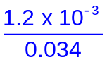
= 0.0353 dm³ or 35.3 cm³ [1]

[4]

[Total: 4]

2 A fullerene is any molecule composed entirely of carbon, in the form of a hollow sphere, ellipsoid, or tube.

Buckminsterfullerene, the molecule C₆₀, was the first fullerene to be discovered.

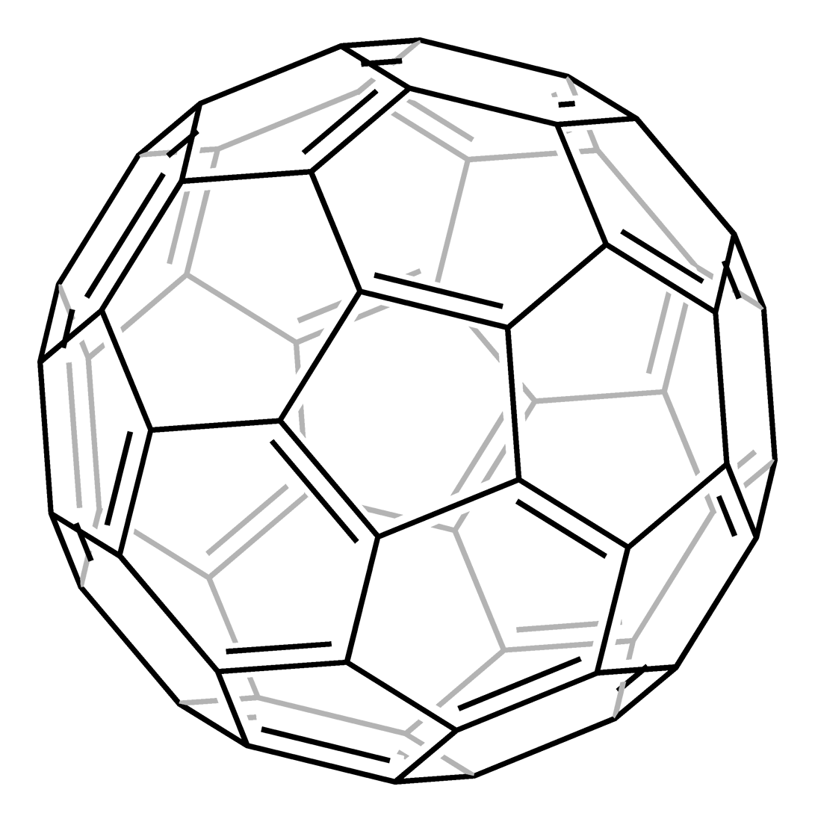

The bonding in buckminsterfullerene is similar to that in graphite.

(a) State the type of bonding between carbon atoms and between C₆₀ molecules in buckminsterfullerene.

Type of bonding:

between carbon atoms: covalent bonds…………………………………………………

between C₆₀ molecules: van der Waals’ forces / td-td / dispersion forces…………[2]

(b) Buckminsterfullerene is soluble in many organic (carbon-based) solvents. Suggest a suitable solvent, explaining your answer.

A specific non-polar solvent which is a liquid at rtp e.g. CCl₄ …………………………

Non-polar solvent will dissolve in non-polar solvent ……………………………………

………………………………………………………………………………………………[2]

(c) Aside from its solubility in organic solvents, suggest another property of buckminsterfullerene which is similar to that of graphite.

Soft / slippery / possess delocalized electrons …………………………………………

………………………………………………………………………………………………[1]

(d) Suggest a property of buckminsterfullerene which is different from that of graphite.

No electrical conductivity / low melting point or boiling point …………………………

………………………………………………………………………………………………[1]

[Total: 6]
3 Sulfuric acid is manufactured industrially by the Contact process. The raw materials are sulfur, air and water.

The flowchart below shows an outline of the Contact process.

S(s) + O₂(g) → SO₂(g)
Stage 1:

2SO₂(g) + O₂(g) 2SO₃(g) ΔH = −197 kJ mol⁻¹

Operating conditions
Temperature: 450 °C
Pressure: 1 atm
Catalyst: vanadium (V) oxide, V₂O₅

Stage 2:

(a) SO₃(g) + H₂SO₄(l) → H₂S₂O₇(l)
oleum

+ H₂O
oleum

Stage 3:
(b) concentrated sulfuric acid

- Sketch graphs to show how the percentage yield of sulfur trioxide in the equilibrium mixture in Stage 2 varies with

(i) pressure for two temperatures, 400 °C and 600 °C, respectively

% sulfur trioxide
Pressure / atm
600 °C
400 °C

(ii) temperature for two pressures, 0.5 atm and 2 atm, respectively.

0.5 atm
2 atm
% sulfur trioxide
Temperature / °C

Temperature / °C

[2]

(b) Suggest how the percentage yield of sulfur trioxide produced in Stage 2 can be increased without varying the operating conditions of the process.

By removing the sulfur trioxide once it is formed. [1]

(c) Write an overall balanced equation for the chemical reactions that happen in Stage 3 to produce concentrated sulfuric acid.

SO₃(g) + H₂O(l) → H₂SO₄(l) [1]

[Total: 4]
4(a) By reference to the CO molecule, explain the meaning of the term bond energy.

The energy required to break one mole of covalent bonds in the gaseous state.

………………………………………………………………………………………………[1]

- Write a thermochemical equation, including state symbols, to represent the average bond energy of C – H in methane.

¼ CH₄(g) → ¼ C(g) + H(g)………………………………………………………………[1]

- With help of the given energy cycle, make use of the following enthalpy changes and appropriate data from the Data Booklet to estimate the average bond energy of C – H in methane.

Enthalpy change of combustion of methane = −882 kJ mol⁻¹.
Enthalpy change of formation of carbon dioxide = −394 kJ mol⁻¹
Enthalpy change of formation of water = −242 kJ mol⁻¹
Enthalpy change of atomisation of carbon = +720 kJ mol⁻¹

ΔH

C(s) + 2H₂(g) + 2O₂(g) ⎯⎯⎯⎯→ CH₄(g) + 2O₂(g)

−882
−394 +2(−242)

CO₂(g) + 2H₂O(l)

ΔH = −394 + 2(−242) −(−882) = +4 kJ mol⁻¹

+4 = Bonds broken − bonds formed
= [720 + 2(436)] − [4E(C – H)]
E(C – H) = +397 kJ mol⁻¹

1 mark for using energy cycle correctly
2 marks for using bond energy method
1 mark for correct answer

[4]

[Total: 6]
5 Sodium was first isolated in 1807 and argon was discovered in 1894. Although they are both in the third period of the Periodic Table, there is considerable variation of properties from sodium to argon.

(a) On the axes below, sketch graphs to show the variation in the following properties of elements across the third period from Na to Ar.
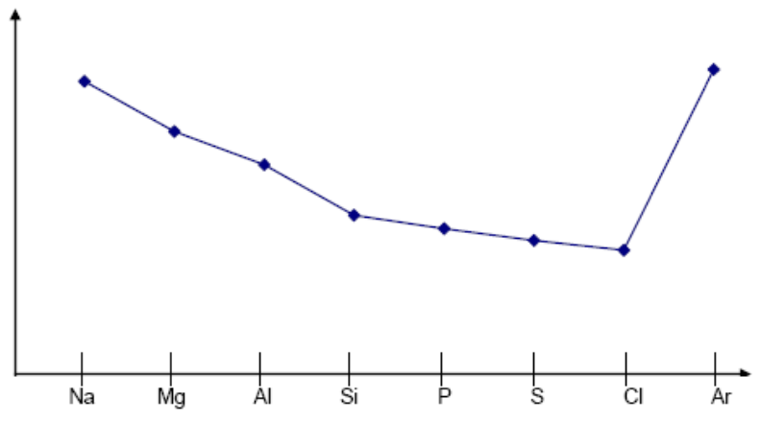
atomic radius
(i)

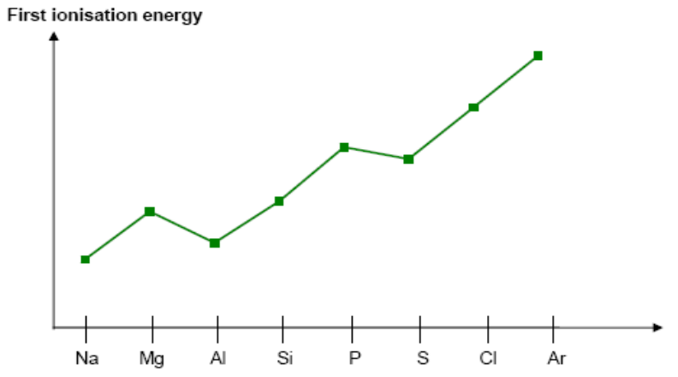
(ii)

[2]

(b) The variation in both atomic radius and first ionisation energy of the third period elements can be explained using nuclear charge, shielding effect and effective nuclear charge.

Explain the term shielding effect and hence use the three terms in italics above to explain the variation in atomic radius.

Shielding effect
The decrease in nuclear attraction experienced by an electron due to it being blocked by inner shell of electrons.
or words to that effect

Variation in atomic radius
Across the period, nuclear charge increase, shielding effect remains relatively constant, effective nuclear charge increase.
………………………………………………………………………………………………[2]
(b) The properties of oxides of the elements of the third period depend on the difference in electronegativity values between the element and oxygen.

The table below shows the electronegativity of elements of the second and third period as proposed by Linus Pauling.

Li  0.98 | Be  1.57 | B  2.04 | C  2.55 | N  3.04 | O  3.44 | F  3.98 | Ne  −
Na  0.92 | Mg  1.31 | Al  1.61 | Si  1.90 | P  2.19 | S  2.58 | Cl  3.16 | Ar  −

(i) Calculate the difference in electronegativity between element and oxygen for the oxides BeO, MgO, Al₂O₃ and SiO₂.

BeO | MgO | Al₂O₃ | SiO₂
1.87 | 2.13 | 1.83 | 1.54

(ii) Hence use your values in (b)(i) to predict the following properties of beryllium oxide, BeO.

• structure and bonding

Giant ionic lattice structure with strong ionic bonds between Be²⁺ and O²⁻ ions.

• pH when added to water

7

• Reactions with aqueous HCl and aqueous NaOH respectively

BeO + HCl → BeCl₂ + H₂O
BeO + 2NaOH + 2H₂O → Na₂Be(OH)₄

accept : BeO + NaOH + H₂O → NaBe(OH)₃
: BeO + 2NaOH → Na₂BeO₂ + H₂O

.......……………………………………………………………………………………
[4]

[Total: 8]
6 Trans-9-oxodec-2-enoic acid is a primer pheromone used by the queen bee to regulate the honeybee caste system.

O
CH₃C(CH₂)₅ H
C=C
H CO₂H

trans-9-oxodec-2-enoic acid

Draw structures of the organic products when trans-9-oxodec-2-enoic acid reacts with

(a) cold dilute KMnO₄

O H H
CH₃C(CH₂)₅−C−C−CO₂H ❶
HO OH

(b) aqueous alkaline I₂

❶ O ❶
CHI₃ and ¯O−C(CH₂)₅ H
C=C
H CO₂¯

(c) HCN with a trace of NaCN

OH ❶
CN
CH₃C(CH₂)₅ H
C=C
H CO₂H

(d) CH₃CH(OH)CH₃ in the presence of concentrated H₂SO₄.

O
CH₃C(CH₂)₅ H ❶ shown as propyl ester
C=C ❷ shown as branched ester
H CO₂CH(CH₃)₂

[6]

[Total: 6]
7(a) Ethanoic acid, CH₃CO₂H, is a stronger acid than ethanol, CH₃CH₂OH.
Explain the above statement.

Strength of acid depends on stability of conjugate base and CH₃CO₂¯ is more stable than CH₃CH₂O¯. ❶

The negative charge in CH₃CO₂¯ is delocalized between the C and O atoms, stabilizing this conjugate base, making the acid strong. ❶

In CH₃CH₂O¯, the ethyl group is electron-donating and pushes electrons towards the negatively charged O atom, making the ion more unstable. ❶
………………………………………………………………………………………………[3]

(b) Give reagents, conditions and observations to show how you would distinguish between the following compounds.

 | CH₃CH₂CH₂Cl | CH₃CH₂CH₂OH
Reagents and conditions | Test 1: Add ethanolic AgNO₃ and warm.  Test 2: Add Na metal  Test 3: Add PCl₅ ❶  Test 4: Add KMnO₄
Observations | Test 1: White ppt formed.  Test 2: No gas evolved. ❶  Test 3: No gas evolved.  Test 4: No decolorisation | No ppt formed.  H₂ gas evolved. ❶  HCl evolved.  KMnO₄ decolorised

[3]

[Total: 6]

Section B
Answer any two of the three questions.
Write your answer on the writing paper provided.

1(a) Many new cars have air-bags which rapidly inflate during an accident and protect the front passengers. The air-bag is inflated with nitrogen released by the rapid decomposition of sodium azide, NaN₃.

- Write a balanced equation for the likely decomposition of sodium azide.

2NaN₃ → 2Na + 3N₂ ………….(i) ❶ eqn
or 3NaN₃ → Na₃N + 4N₂ ………….(ii) ❶ balanced

- What would you consider a likely volume for an inflated air-bag, taking into consideration that it must be big enough to protect a passenger from knocking his head onto the windscreen? Explain your estimation.

Estimated size of air-bag to cover face and distance to windscreen
= 50 x 50 x 30 = 75,000 cm³. ❶ reasoning ❶ volume
(Acceptable answer from Examiner’s Report of 1995 Special Paper Q3(a) is 50 – 200 dm³)

- Based on your answers in (a)(i) and (ii), calculate the mass of sodium azide needed to inflate an air-bag in a motorcar during an accident.

Based on eqn (i), mass of azide = 75 x 2 x 65 = 135.4 g
3 x 24
❶ ❶
or based on eqn (ii), mass of azide = 75 x 3 x 65 = 152.3 g
4 x 24

- Draw a dot-and-cross diagram for the azide ion and suggest its shape.

N N N ❶

Shape is linear. (2 bond pairs and no lone pair at central N)
❶ [8]

(b) Hydrogen azide, HN₃, is a colourless liquid with an irritating odour. It behaves as an acid.

- A 0.1 mol dm⁻³ aqueous solution of hydrogen azide has a pH of 2.9. Explain whether it is a strong or weak acid.

If it is a strong acid, pH = − lg 0.1 = 1.0. ❶ reasoning
Since pH given is 2.9 and not 1.0, therefore it is a weak acid. ❶

- The titration curve when 20 cm³ of this acid is titrated with 0.2 mol dm⁻³ aqueous sodium hydroxide is shown below. Copy the diagram and label the 2 axes. Write down the values of x and y in the spaces provided.
pH

❶

❶
2.9
y

x ❶
Volume of NaOH/cm³

10
❶

- Suggest a suitable indicator for this titration.

Suitable indicator is phenolphthalein. ❶

[7]

- Brefeldin A is an antibiotic.

OH
O

HO O CH₃

Give the structures of the organic products formed when brefeldin A is reacted with the following reagents.

- Bromine dissolved in tetrachloromethane

❶
OH
O
Br
Br

HO O CH₃

- Hot aqueous sodium hydroxide

❶ ❶
OH
OH
ONa

HO O CH₃

- Phosphorus pentachloride

❶
Cl
O

❶ Cl O CH₃

[5]

[Total: 20]

2 Water, H₂O, covers about two-thirds of the Earth’s surface and is vital to life. About 0.005% of water molecules consist of an oxygen atom bonded to two atoms of the hydrogen isotope, deuterium, D.

Deuterium oxide, D₂O, is known as ‘heavy water’ and is used for research in chemical reactions because deuterium atoms react less quickly than normal hydrogen atoms, H. Like H₂O, pure D₂O is weakly ionised.

2D₂O Ý D₃O⁺ + OD⁻

For D₂O, we can use the term K_{D} instead of K_{W} and pD instead of pH.

- Write expressions for the following terms.

(i) K_{D}
K_{D} = [D₃O⁺][OD⁻] [1]

  - pD
pD = – lg [D₃O⁺] [1]
[2]

- For pure D₂O, K_{D} = 1.35 x 10⁻¹⁵. Calculate the values of the following.

  - [D₃O⁺]
[D₃O⁺] = (1.35 x 10⁻¹⁵)^{1/2} = 3.67 x 10⁻⁸ mol dm⁻³ [1]

  - pD
pD = – lg(3.67 x 10⁻⁸) = 7.43 [1]
[2]

- When pure H₂O and pure D₂O are mixed, exchange of H and D atoms takes place and the following equilibrium is established.

D₂O(l) + H₂O(l) Ý 2HDO(l) K_{c} = 3.56 at 298 K

- If a mixture containing 1.5 mol of D₂O and 1.5 mol of H₂O is made up, how many moles of HDO will be present at equilibrium at 298 K?

D₂O(l) + H₂O(l) Ý 2HDO(l)
n_{initial} / mol 1.5 1.5 0
∆n / mol –x –x +2x
n_{final} / mol 1.5 – x 1.5 – x 2x [1]

K_{c} = [HDO]²/[D₂O][H₂O] = 3.56 [1]
(2x/V)²/(1.5 – x/V)² = 3.56 (Assume total volume = V dm³)
2x/(1.5 – x) = 1.886
x = 0.7283 mol
n(HDO)_{eqm} = 2(0.7283) = 1.456 = 1.46 mol [1]

- Describe and explain the effect on the position of this equilibrium if HDO is being drained away once it is formed.
Position of equilibrium would shift to the right [1] to replace the removed HDO. [1]
[5]

- The following list of compounds react with or dissolve in water:

ethanoic acid, ammonia, sodium hydroxide, sodium chloride.

Water can react as either acid or a base. Choose a compound from the above list with which water acts as

- a Bronsted base,
H₂O + CH₃CO₂H Ý CH₃CO₂⁻ + H₃O⁺ [1] ; [1] – identify
- a Bronsted acid.
H₂O + NH₃ Ý NH₄⁺ + OH⁻ [1]

Construct a balanced equation for each reaction. [3]

- A solution containing ethanoic acid and its salt sodium ethanoate, CH₃CO₂Na, acts as a buffer solution.

  - What do you understand by the term buffer solution?
Buffer solution is a solution that resists large changes in pH when small amounts of acid or base are added. [1]

  - Write ionic equations to show how this solution reacts with
I added H⁺(aq) ions,
CH₃CO₂⁻ + H₃O⁺ ↓ CH₃CO₂H [1]
II added OH⁻(aq) ions.
CH₃CO₂H + OH⁻ ↓ CH₃CO₂⁻ [1]
[3]

- Ethanoic acid can be synthesised from ethane by a 3-stage reaction sequence:
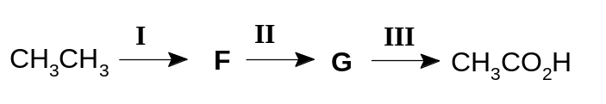
  - Suggest the reagents and conditions necessary for reactions I, II and III.
I: Cl₂ or Br₂, UV light [1]
II: aq NaOH, heat [1]
III: acidified KMnO₄, heat [1]

  - Draw the structural formulae of the intermediates F and G.

F: CH₃CH₂Cl or CH₃CH₂Br; [1]
G: CH₃CH₂OH [1]
[5]
[Total: 20]
3(a) Bones contain a complex mixture of calcium salts, proteins and other material. When a bone is strongly heated in a current of air, the only residue is calcium oxide.

CaCO₃(s) → CaO(s) + CO₂(g)

- Name the type of reaction that occurs when a bone is strongly heated in air.
thermal decomposition

- From a sample of 50.0 g of bone, 14.0 g of calcium oxide were obtained. Calculate the percentage by mass of calcium in the bone.
% by mass of Ca in the bone = 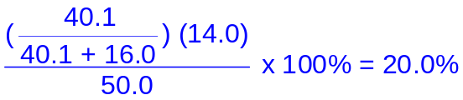

[2]

- Calcium can be obtained from many different sources. Primarily, milk is the richest source of dietary calcium.

The following information was taken from the side of a carton of milk.
How long does your milk keep?

25 °C 0.5 day
18 °C 1 day
10 °C 2 days
5 °C 4 days

- Plot a graph of the time the milk keeps against temperature.

- y-axis: time x-axis: temperature
- Join the points with a smooth curve, not straight lines.
- The curve has a negative slope.

- Use your graph to predict the length of time the milk will keep at a temperature of 15 °C.

1.35 days

- The souring of milk is a chemical reaction.
How is the rate of this reaction related to the length of time the milk keeps?

Rate ∝ 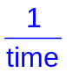

- Explain how and why the rate of souring of milk varies with temperature.

The rate of souring reaction increases with increasing temperature.

At higher temperatures, the average kinetic energy of particles increases. More particles have energy ≥ activation energy. Hence frequency of activated collisions increases. Rate increases.

- Suggest a reason why milk that has been boiled keeps longer than fresh milk.

The catalysts are enzymes which would be denatured at 100 °C.

[8]
(c) Cheese, which is also rich in calcium, contains esters of linoleic acid.

CH₃(CH₂)₄CH=CHCH₂CH=CH(CH₂)₇CO₂H
linoleic acid

On the lid of a brand of cheese it is claimed that the cheese contains virtually no trans fatty acids.

Representing the formula by the abbreviated structure A−CH=CHCH₂CH=CH−B, draw the structural formula of the isomer of linoleic acid that could be present in the cheese.

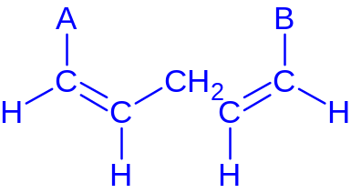

[2]

(d) An organic compound, A, has the following composition by mass.
C, 60.0%; H, 13.3%; O, 26.7%

It has a relative molecular mass of 60.

When A is heated under reflux with an excess of acidified K₂Cr₂O₇, the solution turns from orange to green and Compound B is formed. B turns moist blue litmus paper red.

However, heating A with acidified K₂Cr₂O₇ followed by immediate distillation gives a compound C.

When 2,4-dinitrophenylhydrazine is added to C, an orange-yellow crystalline solid is produced. C also reacts with Fehling’s solution and Tollen’s reagent.

(i) Calculate the molecular formula of A.
C₃H₈O

(ii) Identify the compounds A, B and C. Write clearly the deductions that you made from the information given.

A is CH₃CH₂CH₂OH.
B is CH₃CH₂CO₂H.
C is CH₃CH₂CHO.

- A → B
Observations: B turns moist red litmus paper red.
The colour of the solution turns from orange to green.
Deductions: B is a carboxylic acid.
So, A must be a 1° alcohol.
The orange K₂Cr₂O₇ solution turns to green Cr³⁺ solution.

- A → C
Observations: C reacts with 2,4-DNPH to form an orange-yellow crystalline solid.
C also reacts with Fehling’s solution and Tollen’s reagent.
Deductions: C must be an aldehyde.
C reacts with Fehling’s solution to form a brick-red ppt.
C reacts with Tollen’s reagent to form a silver mirror.

[8]

[Total: 20]

End of Paper

